Uteweg 12
Willemstad
Curaçao
T: +31 6 42250867

IND-unit Caribbean Netherlands
DATE
Subject: Application for Declaration of Lawful Stay
This letter serves to formally invite [FULL NAME] for an internship with the organisation De Kracht van Sport, during the period from [START DATE] to [END DATE].
His/her place of residence during this period will be:
Uteweg 16
Willemstad
Curaçao
[FIRST NAME] will reside at this address for the entire duration of his/her stay in Curaçao.
We will ensure that [FULL NAME] complies with all relevant immigration laws and regulations of Curaçao prior to and during his/her stay on the island.
We kindly ask for your assistance in facilitating the application for the Declaration of Lawful Stay for his/her internship.
Please do not hesitate to contact me should you require any further information.
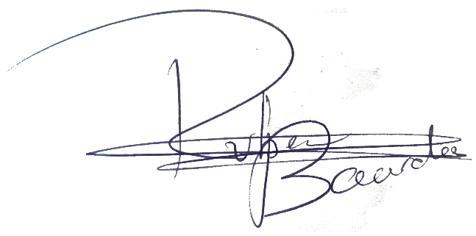
Thank you for your time and attention.

Ruben Baarda
Email: info@thepowerofsports.co.uk

